PRODUCT NAME: PATCH Part B Resin
SECTION 1: PRODUCT AND COMPANY IDENTIFICATION
PRODUCT CODES: PATCH Epoxy Part B Resin
MANUFACTURER/ DISTRIBUTOR:
Terrazeco, LLC
123 Main St.
Hookerton, NC 28538
1-252-747-3735
PRODUCT USE: Floor Coating
CHEMICAL SPILL
EMERGENCY PHONE: 800-255-3924
CHEMTEL PHONE: 800-255-3924
SECTION 2: HAZARDS IDENTIFICATION

GHS Classification in accordance with 29 CFR 1910 (OSHA HCS)
Acute toxicity - Oral Category 4
Skin corrosion -Category 1C
Serious Eye Damage -Category 1
Skin Sensitization - Category 1
Specific target organ toxicity - repeated exposure - Oral Category 2
Label Elements
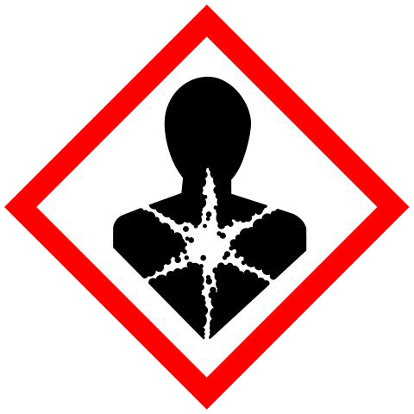
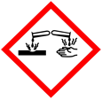
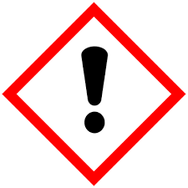
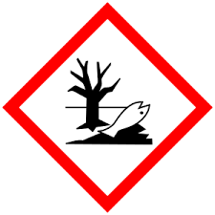
Hazard pictograms/symbols:

Signal Word: Danger
Hazard Statements:
H302: Harmful if swallowed.
H314: Causes severe skin burns and eye damage.
H317: May cause an allergic skin reaction.
H373a: May cause damage to organs through prolonged or repeated exposure if swallowed.
Section 3: COMPOSITION/INFORMATION ON INGREDIENTS
INGREDIENTS | % BY WEIGHT | CAS #
Aliphatic Polyamine | 30-40% | TS
Phenol, 4-nonyl-, branched | 20-25% | 84852-15-3
Titanium dioxide | 20-25% | 13463-67-7
SECTION 4: FIRST AID MEASURES

EYES: Immediate and continuous irrigation with flowing water for at least 30 minutes is required. Promptly seek medical attention.
SKIN: Immediately flush skin with plenty of water for at least 15 minutes while removing contaminated clothing, preferably under a safety shower. Seek medical attention immediately. Avoid prolonged or repeated contact to skin. Wash thoroughly after handling.
INGESTION: Do not induce vomiting. Give large amounts of water or milk if available and transport to medical facility.
INHALATION: Remove to fresh air if effect occurs. Consult medical personnel.
NOTES TO PHYSICIANS: Corrosive. May cause stricture. Lavage is performed, suggest endotracheal and/or esophagoscopic control. If burn is present, treat as any thermal burn, after decontamination. No specific antidote. Supportive care. Treatment based on judgment of the physician in response to reactions of the patient. Application of corticosteroid cream has been effective in treating skin irritation
Section 5: FIRE FIGHTING MEASURES
FLAMMABLE LIMITS IN AIR (% BY VOLUME): UPPER LIMITS: N/A LOWER LIMITS: N/A
FLASH POINT: 213 °F (100.56°C)
METHOD USED: PMCC
NFPA HAZARD RATING: 4 = EXTREME; 3 = HIGH; 2 = MODERATE; 1 = SLIGHT; 0 = INSIGNIFICANT
NFPA HAZARD HMIS HAZARD
CLASSIFICATION: CLASSIFICATION:
HEALTH: 2 HEALTH:
FLAMMABILITY: 1 FLAMMABILITY:
REACTIVITY: 0 REACTIVITY:
OTHER: N/A OTHER:
EXTINGUISHING MEDIA: Water Fog, Alcohol Foam, CO2, or Dry Chemical
FIRE FIGHTING PROCEDURES: Wear positive pressure SCBA
UNUSUAL FIRE AND EXPLOSION HAZARDS: Use full protective clothing (see section 8).
Section 6: ACCIDENTAL RELEASE MEASURES

LARGE SPILL: Dike up and pump into appropriate containers.
SMALL SPILL: Use noncombustible absorbent materials and shovel into suitable containers.
Section 7: HANDLING AND STORAGE
PRECAUTIONS FOR SAFE HANDLING:
Ground all transfer equipment. Hold bulk storage under a nitrogen blanket. This product should not come in contact with copper or copper-bearing alloys. Good general housekeeping procedure should be followed.
CONDITIONS FOR SAFE STORAGE:
Do not store near acids. Keep containers tightly closed in a dry, cool and well-ventilated place.

Section 8: EXPOSURE CONTROLS/PERSONAL PROTECTION
EXPOSURE GUIDELINE(S): N/A
VENTILATION: Control airborne concentration below the exposure guideline. Use only with adequate ventilation. Local exhaust ventilation may be necessary for some operations.
RESPIRATORY PROTECTION: Atmospheric levels should be maintained below the exposure guideline. When respiratory protection is required for certain operations, use an approved air purifying respirator.
EYE PROTECTION: Use chemical goggles if vapor exposure causes eye irritation, use a full-face respirator. Eye wash fountain should be located in immediate work area.
SKIN PROTECTION: Use protective clothing impervious to this material. Selection of specific items such as gloves, boots, apron, or full-body suit will depend on operation. Safety shower should be located in immediate work area. Remove contaminated clothing immediately, wash skin area with soap and water, and launder clothing before reuse. Contaminated leather items, such as shoes, belts and watchbands, should be removed and destroyed.
Section 9: PHYSICAL AND CHEMICAL PROPERTIES
APPEARANCE: Straw colored liquid.
ODOR: Amine Odor
PHYSICAL STATE: Liquid
BOILING POINT: 405° F (207° C)
VAPOR PRESSURE: < 10.37 mmHg
VAPOR DENSITY (AIR = 1): 5.88
SPECIFIC GRAVITY (H2O = 1): 1.01
Viscosity: 450mPa.s at 73F(23C)
Section 10: STABILITY AND REACTIVITY

CONDITIONS TO AVOID (STABILITY): Can react strongly with epoxy resins at elevated temperatures.
INCOMPATIBILITY (MATERIAL TO AVOID): Epoxy resins under uncontrolled conditions.
HAZARDOUS DECOMPOSITION OR BY-PRODUCTS: Nitrogen oxides when burned.
HAZARDOUS POLYMERIZATION: Will not occur.
Section 11: TOXICOLOGICAL INFORMATION
11.0 TOXICOLOGICAL INFORMATION
11.1 Likely routes of exposure: N/A
11.2 Symptoms related to the physical, chemical and toxicological characteristics:
Ingestion: Ingestion may cause gastrointestinal irritation or ulceration. Ingestion may cause burns of mouth and throat. Aspiration into the lungs may occur during ingestion or vomiting, causing tissue damage or lung injury.
Skin Contact: Prolonged or widespread skin contact may result in absorption of harmful amounts.
Irritation:
Skin: Brief contact may cause severe skin burns. Symptoms may include pain, severe local redness and tissue damage Skin contact has caused allergic skin reactions in certain sensitized individuals.
Eyes: May cause pain disproportionate to the level of irritation to eye tissues. May cause severe irritation with corneal injury which may result in permanent impairment of vision, even blindness. Chemical burns may occur.
Inhalation: May cause allergic respiratory response. Excessive exposure may cause irritation to upper respiratory tract (nose and throat).
11.3 Delayed and immediate effects and also chronic effects from short and long term exposure:
Carcinogen: This product contains no materials that are reported as known or suspect carcinogens in levels above 0.1%. Mutagen: This product contains no materials that are reported as known or suspect mutagens in levels above 0.1%.
Reproductive Hazard: This product contains no materials that are known or suspected of causing a reproductive hazard in levels above 0.1%.
Section 12: ECOLOGICAL INFORMATION
11.4 Numerical measures of toxicity: N/A

12.1 Ecotoxicity: No information available.
12.2 Persistence and degradability: N/A
12.3 Bioaccumulative potential: N/A
12.4 Mobility in soil: N/A
12.5 Other adverse effects: N/A
13.1 Disposal methods:
Section 13: DISPOSAL CONSIDERATIONS
Preferred method of disposal includes incineration under controlled conditions in accordance with all local and national laws and regulations. The generation of waste should be avoided or minimized wherever possible. Untreated material is not suitable for disposal. Waste, even small quantities, should never be poured down drains, sewers or watercourses.
Waste must be disposed of in accordance with federal, state and local environmental control regulations. This material, when properly mixed and cured with its resin component at the proper mix ratio, may be safely land filled. Contaminated packaging: empty containers can only be disposed of when the remaining product adhering to the container walls has been removed. Hazard warning labels should be removed from the container only after it has been properly emptied.
Section 14: TRANSPORT INFORMATION

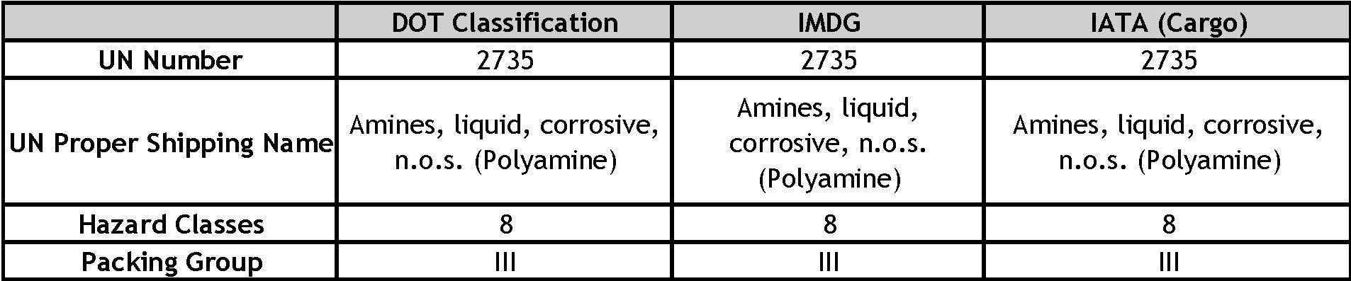
Section 15: REGULATORY INFORMATION

U.S. FEDERAL REGULATIONS:
TSCA (TOXIC SUBSTANCE CONTROL ACT):
The components of this product are contained on the chemical substance inventory list.

CERCLA (COMPREHENSIVE RESPONSE COMPENSATION, AND LIABILITY ACT):
Requires notification of the National Response Center of release of quantities of Hazardous Substances equal to or greater than the reportable quantities (RQ's) in 40 CFR 302.4. Components present in this product at level which could require reporting under the statute are:
Chemical Name | CAS Number | % By Weight | RQ
NONE | N/A | N/A | N/A

SARA TITLE III (SUPERFUND AMENDMENTS AND REAUTHORIZATION ACT):
Sections 301-304 require emergency planning based on Threshold Planning Quantities (TPQs) and release reporting based on Reportable Quantities (RQs) in 40 CFR 355. Components present in this product at a level which could require reporting under this statute are:
Chemical Name | CAS Number | % By Weight
NONE | N/A | N/A

311/312 HAZARD CATEGORIES:
Sections 311-312 require products be reviewed and applicable EPA Hazard Definitions be identified and made known.

EPA HAZARD CLASSIFICATIONS:
Acute Hazard  YES | Chronic Hazard  YES | Fire Hazard  NO
Pressure Hazard  NO | Reactive Hazard  NO
313 REPORTABLE INGREDIENTS:
Section 313 requires submission of annual reports of release of toxic chemicals that appear in 40 CFR 372 (for SARA 313). This information must be included in all MSDSs that are copied and distributed for this material. Components present in this product at level which could require reporting under the statute are:
Chemical Name | CAS Number | % By Weight
NONE | N/A | N/A
SECTION 15 NOTES: If you are unsure if you must report more information, call the EPA Emergency Planning and Right-To-Know Hot Line: 800-535-0202 or 202-479-2449. The concentrations shown in this document are maximum or ceiling levels (expressed in weight %, unless otherwise specified) to be used for regulations. Trade Secrets are indicated by "TS".
Section 16: OTHER INFORMATION

The information herein is given in good faith, but no warranty expressed or implied is made. TERRAZECO, LLC urges suppliers and users of this product to evaluate its suitability and compliance with local regulations as TERRAZECO, LLC cannot foresee the nature of the final application nor final location of usage

